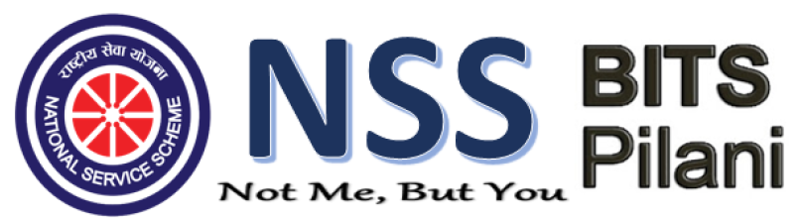

Annual Report
2018-19

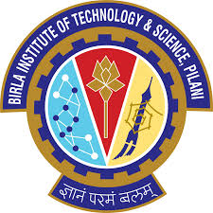

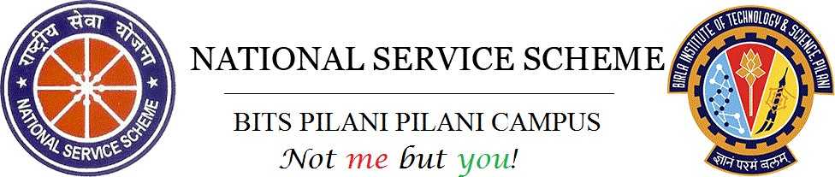

ANNEXURE 1

UNIT-WISE ACTIVITES REPORT

NSS BITS Pilani comprises of enthusiastic and dedicated volunteers who are well- guided by the esteemed professors to help them build sustainable and comprehensive models for the betterment of people in Pilani and nearby villages including Bhaas, Harinagar, Garinda, Ghumansar, Jherli, and Rayla. It also aims to inculcate a spirit of service in the volunteers which will help them in becoming responsible citizens dedicated to the improvement of our nation and the world at large in every aspect. It also aims to eradicate various stereotypes and malpractices by spreading awareness in villages near Pilani. All the major divisions of NSS: education, health and awareness play their role in this process to make the country a better place to live in. The main motto is to create a better society by helping as many people as possible. A special focus is laid upon women empowerment and child development.

Index

- PILANI
- NSS School
- Computer Literacy Program
- English and Personality Development Sessions
- Teacher’s Day Celebration
- Counselling Sessions
- Gandhi Jayanti Celebration and Swachch Bharat Mission
- Children’s Day Celebration
- Unsung Heroes and Junoon 2k18
- Oasis Stalls
- Sports Day for School Students
- Blood Donation Camp 2019
- Conferencia De Youth

- HARINAGAR
- Computer Literacy Program
- Independence Day Celebration in Harinagar School
- Government School Initiative
- Republic Day Celebrations

- RAYLA
- Independence Day Celebration
- Health Camp in Rayla
- Computer Literacy Program (CLP)
- Sports Day Celebration

- GARINDA
- Swachch Bharat Mission
- Independence Day Celebration
- CCC Publicity (CLP)
- Lecture Series Initiative

- JHERLI
- Gandhi Jayanti Celebration
- Government School Initiative
- Green School Initiative
- Lecture on Good Touch – Bad Touch
- Computer Literacy Program
- Awareness Rally for Blood Donation Camp

- BHAAS
- Government School Initiative
- Project BHOOMI
- Scheme Portal
- Counselling Sessions
- Computer Literacy Program

- GHUMANSAR
- Computer Literacy Program Publicity
- Adult Initiative
- Lecture on ‘Anaemia: Symptoms and Precautions’
- Documentation Camps

  - PILANI

NSS SCHOOL BITS Pilani stands for educating the underprivileged started their working by conducting an entrance exam for interested students at the beginning of the academic session. Each volunteer was allotted 4 days a week, on which they come and teach the allocated students. School functions for 7 days a week with 6 days of regular studying and one day it conducts workshops and tests for overall development. For effective learning of students, School maintained a 2:1 ratio student-volunteer ratio. Two new programs were launched this year, both with aims related to their vision. These were English Learning Program (ELP) and Unnati.
ELP- The objective of this program is to make students capable enough to understand the meaning of questions asked in English and hold a basic conversation in English. The program is aimed to be done in the last 15 minutes of regular teaching so that it not only provides a respite to the students from regular teaching but also does not hamper it.
Unnati- Project Unnati was started with a mission to help engineering and medical aspirants in and around Pilani area in preparing them for JEE Mains and NEET respectively. Tests were conducted across various schools in Pilani to filter out the students for the program.

Apart from this, two parents teacher meets were conducted in the past year to know their opinions about their children as well as to make them realize the importance of their children’s regularity in school. Home visits of the students were conducted to gauge the condition of the child accurately. These visits help the volunteers know the background of the child and various problems that the child is facing in academics as well as his personal life. These home visits also act as a feedback system as parents can express their views on the counselling team that has been created to motivate children to excel in their curricular as well as co-curricular activities. It also conducts sessions wherein students of class 10th and 12th are guided on various career choices they could pursue in future and the choice of discipline they need to choose to pursue the same. School aims for the holistic development of the students. For this, Sports Day was organized on January 20th, 2019 where students of School participated in sports like Kho-Kho, Lemon Race, Tug of War, etc. An annual school recreational event UDAAN was also held on April 7th, 2019, which provided students an opportunity to show their talents in the field of Dance, Drama, Poetry, and Music.

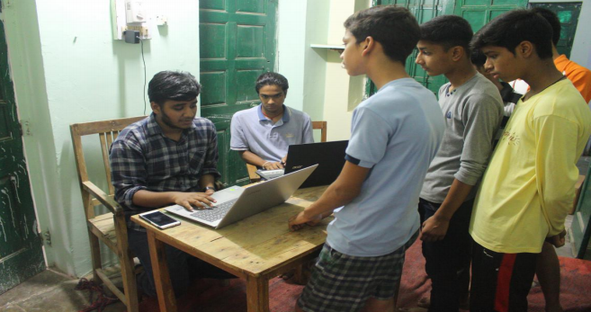
Volunteers registering the applicants

COMPUTER LITERACY PROGRAMME is an initiative taken by the volunteers of NSS BITS Pilani to teach the basics of computers to the locals of Pilani. These basics help many locals because nowadays, even the smallest jobs require elementary computer skills and knowledge. Many students ranging from school going kids to students from degree colleges have been benefitted from this initiative this year. CLP organized coding classes for the students of NSS School to facilitate them with basic knowledge of coding and related concepts.

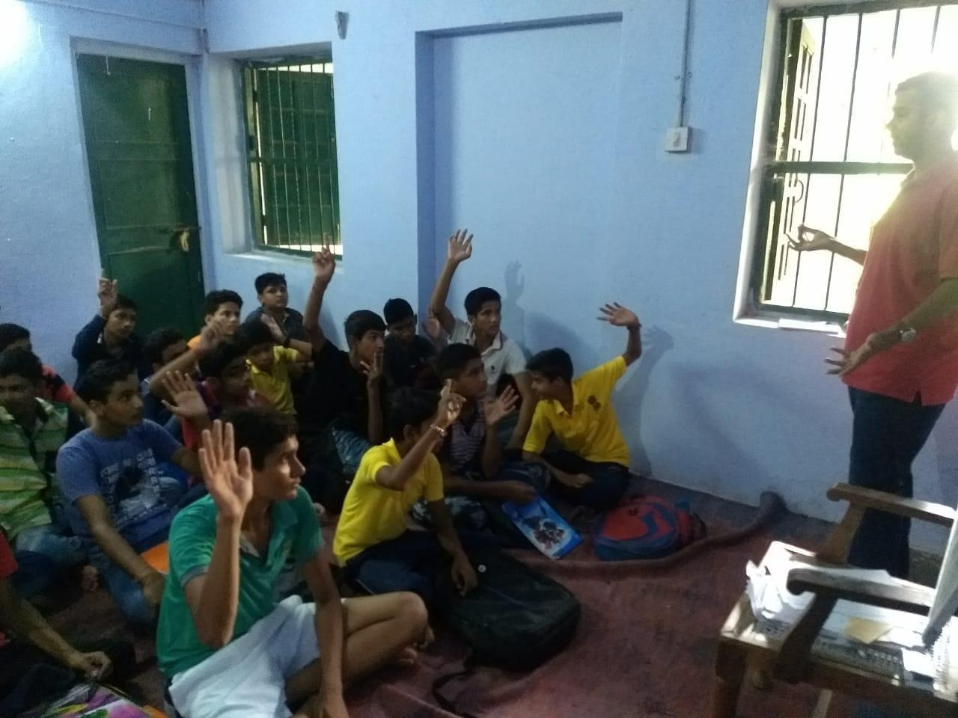
Volunteers teaching students the basics of coding

Workshop on Fundamentals of Computer Learning
Taking a step further towards all-round development of students and aiming to give them skills to compete in the modern world, a workshop was organized on the Fundamentals of Computer Learning on 2nd Sept. 2018. As a part of this workshop, students were taught various basic information needed for using computers and surfing the internet such as using Google, Wikipedia, YouTube, my CBSE guide, etc.
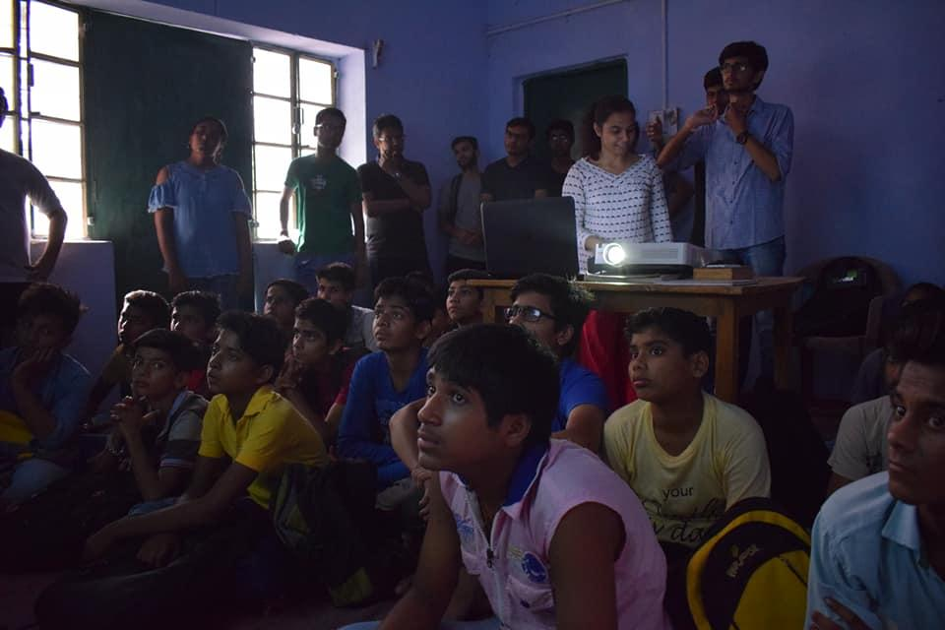
Volunteers interacting with School Students

The ENGLISH AND PERSONALITY DEVELOPMENT team comprises of volunteers who are efficient in English and communication. The work of this session was started by conducting a test to know the progress of the students in the recent past.

EPD is presently focusing on classes 7th, 8th, 9th, and college students. Regular classes were conducted every Saturday and Sunday. Grammar topics such as Sentences, Nouns, Verbs, Pronouns, Adjectives, etc. were taught by the volunteers. The classes were a mix of black board teaching and activities like role play, speech giving competition. The winners of the speech giving competition were provided books and comics as gifts.

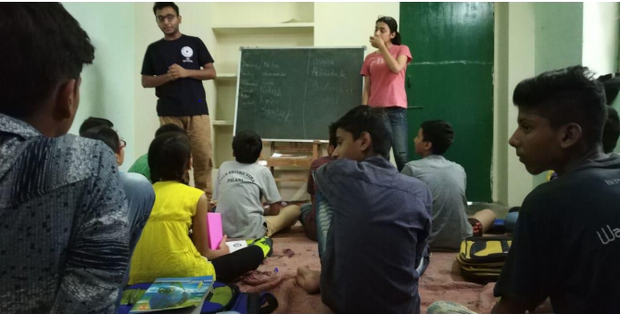
NSS Volunteers teaching students the importance of English.

CONTENT IN BRIEF –

- Writing skills- Notice writing, Message writing, E-mail writing, letter writing etc.
- Workshops – To emphasize on some particular aspects or to address a common problem.
- Comprehensive skills - Various types of comprehensions were covered in order to improve their analytical and qualitative skills. This was complemented by reading, understanding and then re-producing it in their words.

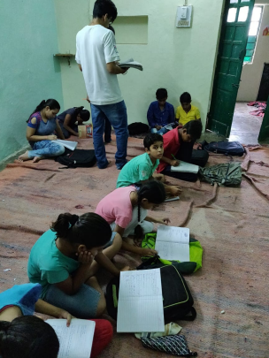
Students completing a writing task given to them.

Teacher’s Day Celebration:
No man can be a good teacher unless he has feelings of warm affection towards his pupils and a genuine desire to impart to them what he believes to be of value. Keeping this in mind, NSS School celebrated Teacher’s Day with all of its students and volunteers. After regular teaching, students were asked to make cards for their respective mentors. Students readily participated in the same, showing their innermost affection towards them and the School. This was followed by games, dancing and more activities, the aim of which was to strengthen the bond between students and their volunteers. The day ended with the volunteers finding their cards on the card tree and getting delighted by the students’ respect and affection for them.

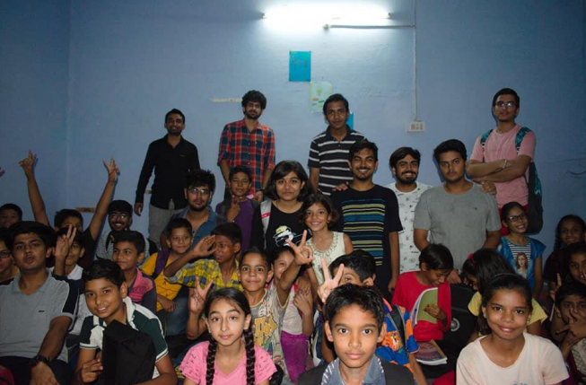
Volunteers and students both enjoying on Teacher’s Day

COUNSELLING SESSIONS
Several Counselling sessions were organised in Vashistha Pathak, NSS School and Padia. The sessions aimed at guiding the students and showing them a path towards a bright future. Also, it focused on making their base strong to help them prevail in this competitive world. Tips related to the upcoming board exams were given through a unique skit that helped the students a lot. Addressing a mixed audience of around 40 kids in NSS School, Vashistha Pathak and over 100 in Padia, ranging from 9th to 12th standard, the speakers talked about the importance of studies and various streams leading to vast number of degrees.
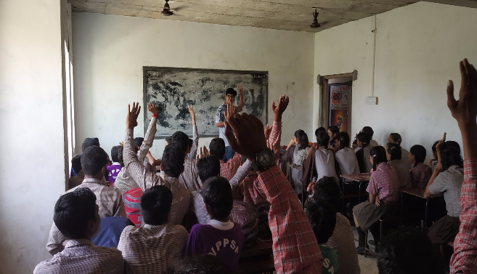
Volunteer interacting with students during counselling session in Vashishth Pathak School

Sessions were of 1-1.5-hour duration with underlying theme to motivate 9th -12th class students to inculcate a spirit of studying and importance of studies was made clear with the proper use of real-life examples and illustrations by the speakers. The speakers elaborated on the problems and distractions faced by students while studying and suggested simple and innovative solutions. Tips related to time management and study techniques were also shared.
The sessions were concluded with general doubt clearing sessions. It was made sure that the students take back the maximum from these sessions and incorporate the tips in their lives.

Children’s Day Celebration:
On the chilly evening of November 14, NSS School was as chirpy and bubbly as ever on the evening of Children's day! But there were no study lessons that day. The environment created by the volunteers gave the festival vibes. The children's excitement was tangible as they went through the different activities planned for them. Students of classes 1st - 3rd showed off their creativity in a drawing competition. An animated movie was also screened for them. Various activities were planned for the older kids including Pictionary and passing the parcel. Dumb charades and dodgeball were universal hits, with students from almost all the classes participating.

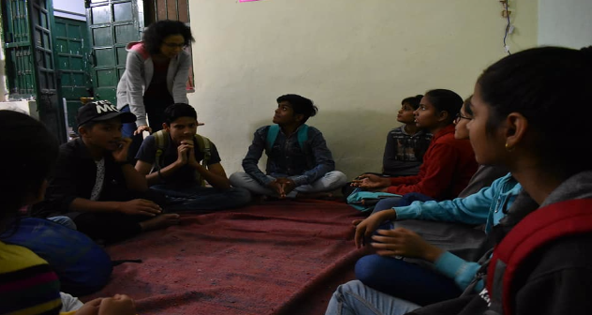
Students and volunteers participating in games organized by the NSS School

Gandhi Jayanti Celebration and Swachch Bharat Mission:
Taking a step forward on the way shown by Gandhiji. NSS School conducted a workshop for classes 1st to 10th to mark the birth anniversary of Gandhiji. Children were made aware of government Swachh Bharat Program, its importance and how they can make their surrounding clean. Thereafter they were taught how they can improve their focus in studies by meditation. They followed the live demonstration of OM chanting, Pranayam etc.
This was followed by a special session of 15 minutes for girls of class 6th to 10th on menstruation hygiene, they learned about the Menstrual Hygiene Management(MHM). Class 1st to 3rd were told stories of Gandhiji and his struggle for freedom with non-violence. After that, they were asked to write slogans related to cleanliness and Indian army. Students of class 4th , 5th, and boys of class 6th to 10th were encouraged to draw posters on bravery and courage of the Indian Army to mark the 2nd anniversary of the surgical strikes carried out by the Army across the Line of Control(LoC).
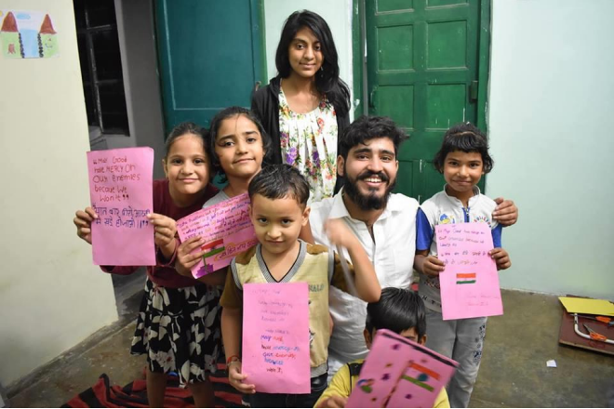
Slogans written by the students

UNSUNG HEROES
The pre Junoon talk series, Unsung Heroes was conducted on 9 th sept. in the NAB auditorium. The speakers for the event were Mr. Navin Gulia and Ms. Ritu Saini. Mr. Navin Gulia is an Ex-Army Officer with multiple awards, a brilliant author and an adventurer. He lost his legs in an accident but never lost his zeal. Ms. Ritu Saini is a Victim of a cowardly acid attack, participated in numerous fashion events, raises awareness about acid attack victims.
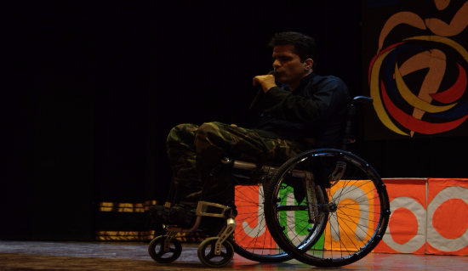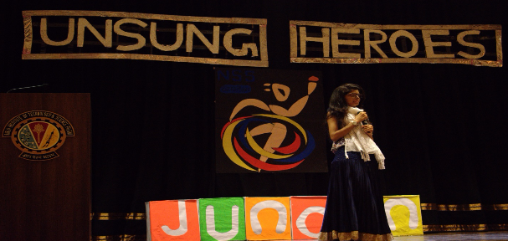

Mr. Navin Gulia told many small instances from his life and gave many life lessons from them. The audience was amused by his adventurous stories and his poetic means of communication. Ms. Ritu Saini told about the attack and how she rose above everything and became what she is now. She also highlighted the problems faced by the acid attack victims. She also talked about the initiative SHEROES, which was highly applauded.
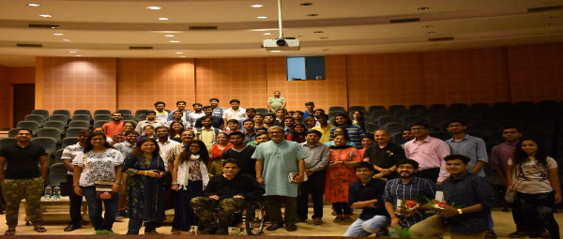
Both the talks were highly appreciated by the audience and was a great learning experience for everybody present over there.

JUNOON 2K18
Junoon 2018 had a kick start with the inauguration ceremony held at SAC. The chief guest of this auspicious event, Padma Shri Murlikant Petkar was welcomed with a bouquet followed by his speech. Sh. Murlikant Petkar's motivational speech had a charge of his struggle times and carving out him to what he is today. Later that day, recreational activities were organized for the specially abled kids. Children were taken for a photo session while many participated in activities like Ludo, Kho-Kho, Football, Volleyball, etc.

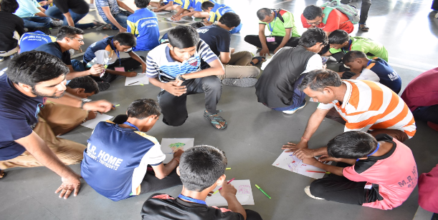
Recreational Activities

After the exciting 1st day, the second day started with sporting and athletic events in gym-grounds at 8:00 am. Events like the 100m race, 50m race, bocce, shot-put, standing jump were organized for the participants. The programme concluded with the prize distribution ceremony.
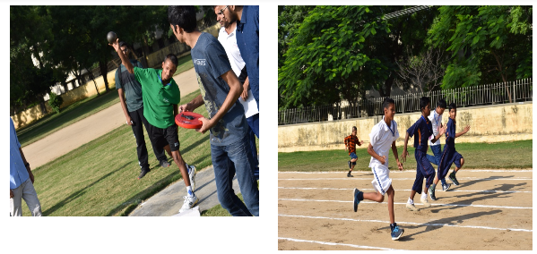
Sporting Events on Day 2
The event concluded with Junoon Nite in the main auditorium in which there were some amazing performances put up by the participants. After the performances, the NGOs were awarded medals and trophies.
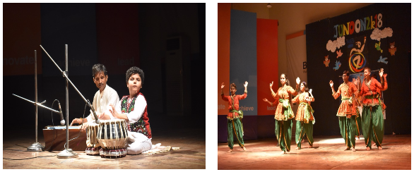
Performances by the children

OASIS STALLS 2018
NSS BITS Pilani organized NSS OASIS STALLS 2018 during OASIS
2018, the annual cultural festival of BITS Pilani. This year the Stalls included three events-
• EYE DONATION CAMP
• LEND YOUR VOICE
• SHOP FOR A SMILE
NSS BITS Pilani organized Eye Donation Camp in collaboration with Eye Bank Association of India (EBAI) and Urvi Ashok Piramal Foundation (UAPF). The camp was aimed at raising awareness among the young minds about the importance of eye donation. The camp saw a positive response from students from various colleges, professors and local Pilani residents. The camp was a huge success with over 530 people pledging to donate their eyes after their demise. All those who pledged received a donor’s card and all the pledge forms were handed over to EBAI.
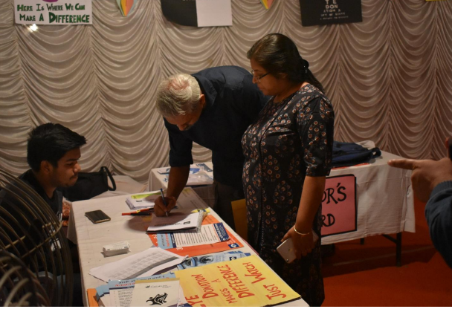
Professors pledging their eyes

Lend Your Voice (LVY) was organized to create the largest repository of audiobooks for the blind children. We collaborated with Team Aawaz from IIT Bombay for the same. A huge set of 400 audiobooks were recorded by students, kids, professors and the elderly. The audiobooks contain various short stories and poems which will be donated to various blind schools across India by Team Aawaz.
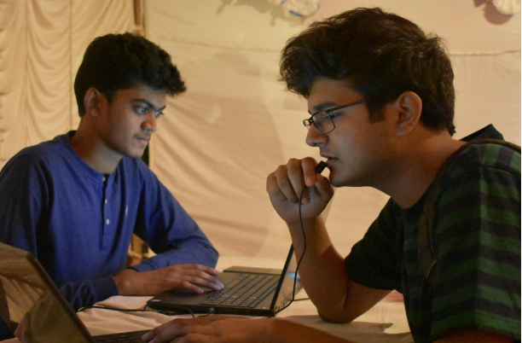
A person recording an audiobook

This year’s edition of Shop For A Smile saw participation from 20 NGOs. The NGOs were from Delhi, Jaipur, and Pilani. The event showcased products made by specially-abled children, elderly people, rural women, and rape victims. The shop was inaugurated by Prof. A.K. Sarkar on 28th October along with Dr. Ashish Tiwari, Dr. S K Verma and Dr. Navin Singh. They visited the shop, admired all the products and motivated the volunteers to keep giving back to the society.
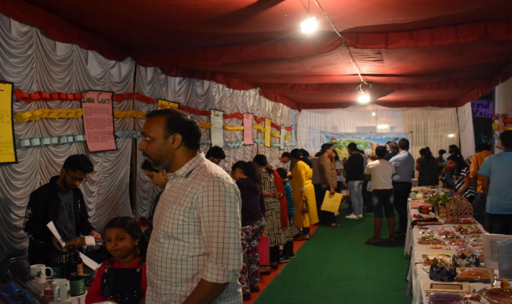
Blood Donation Camp 2019:
The Blood Donation Camp 2019 (BDC 2019) was conducted by NSS, BITS Pilani, along with the help of Indian Red Cross Society, New Delhi. This was the 38th edition of Blood Donation Camp. The camp took place on 2nd and 3rd February 2019. It was a two day camp which was open from 9AM to 9PM. The Camp was inaugurated by the Vice-Chancellor, Director and various other Faculty members of BITS Pilani on Saturday 2nd February at 9 AM.
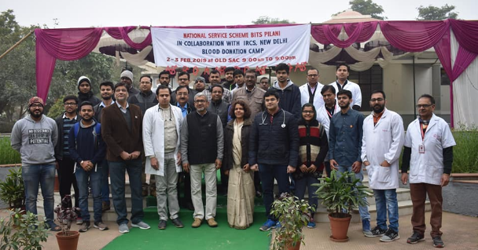
Inauguration of the Blood Donation Camp
The camp saw a total of 748 units collected, along with the footfall of over 1000+, which was a great achievement in itself.
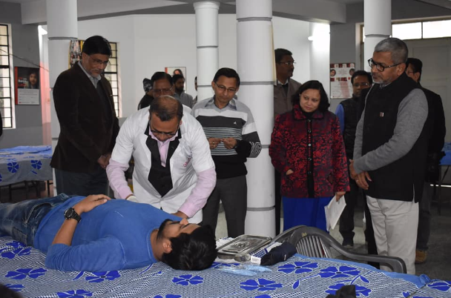
Blood Donation process by a Donor

Conferencia de Youth:
With the vision that the it is the people especially the youth who have to safeguard the interests of the nation and of their own, NSS BITS Pilani organized the inaugural edition of “Conferencia de Youth,” a youth conference for the social chapters of different colleges spread across Delhi, Jaipur and other cities. The inaugural edition has the theme as ‘ROLE OF YOUTH IN NATION BUILDING’. There were about 7 outstation colleges which saw a participation of 48 students for the conference.
The conference had a total of 9 events :
- Listen, Talk, Change – Talk by the honourable Chief Guest Mrs. Medha Patkar.

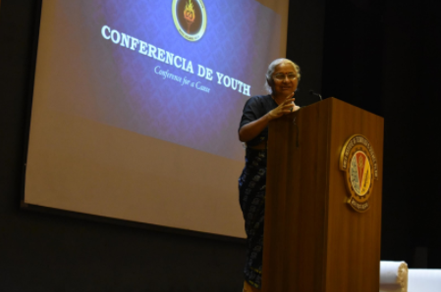

- Masterplan - Business Plan Presentation on Social Entrepreneurship.

- Code-a-thon - Hackathon to develop technological solution for a social issue.

- Educate, Empower – Teaching school kids in an innovative manner.
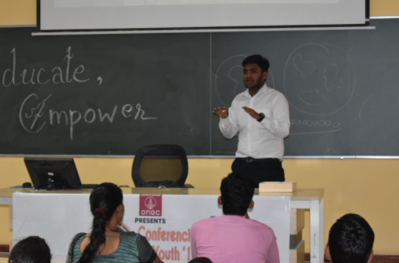
- Eloquence - Group Discussion.

- Mukhaute - Street Play on a social cause.

- Adhyayan - Case study competition.

- Words of Wisdom - Talks by the guests of the conference, Mr. Shantanu Gupta and Mr. Nipun Malhotra.

- Volunesia – Work Presentation of the social chapters.

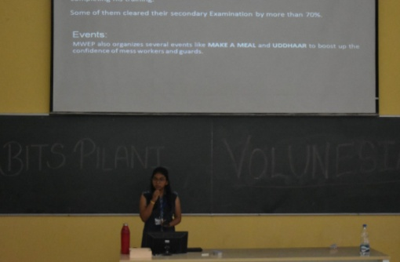

  - HARINAGAR
Computer Literacy Program (CLP)
With the propensity to impart computer education to all sections of Indian society, CLP initiated with ‘Course on Computer Concepts’ (CCC) which helps the students to learn the basics of computers. CCC is a three-month-long Central government certified computer course conducted by NIELIT. This course is designed to aim at imparting a basic level IT education to the common man. The first batch of CCC in PRC started on 22nd October 2018, whereas the second batch started on 29th January 2019. As there is no age limit for this course, anyone can register for it.

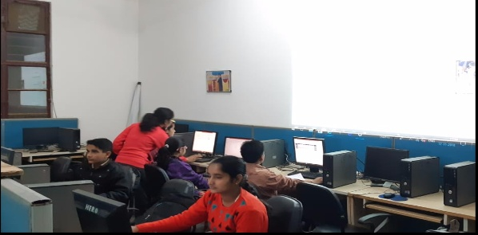
CCC being conducted in Pilani Resource Center

Independence Day Celebrations:
A celebration was organised by Computer Literacy Program Department of NSS, BITS Pilani, on the occasion of Independence Day in the Government School. A seminar was conducted to increase the awareness of the on-going frauds which are now becoming prevalent in our society. The major topics of seminar were sim-card cloning, ATM frauds, Aadhaar card frauds and lottery message frauds. A drawing competition was also conducted for students of classes 6th to 8th, in which they showcased their artistic talents by making a drawing on the theme of Independence Day.
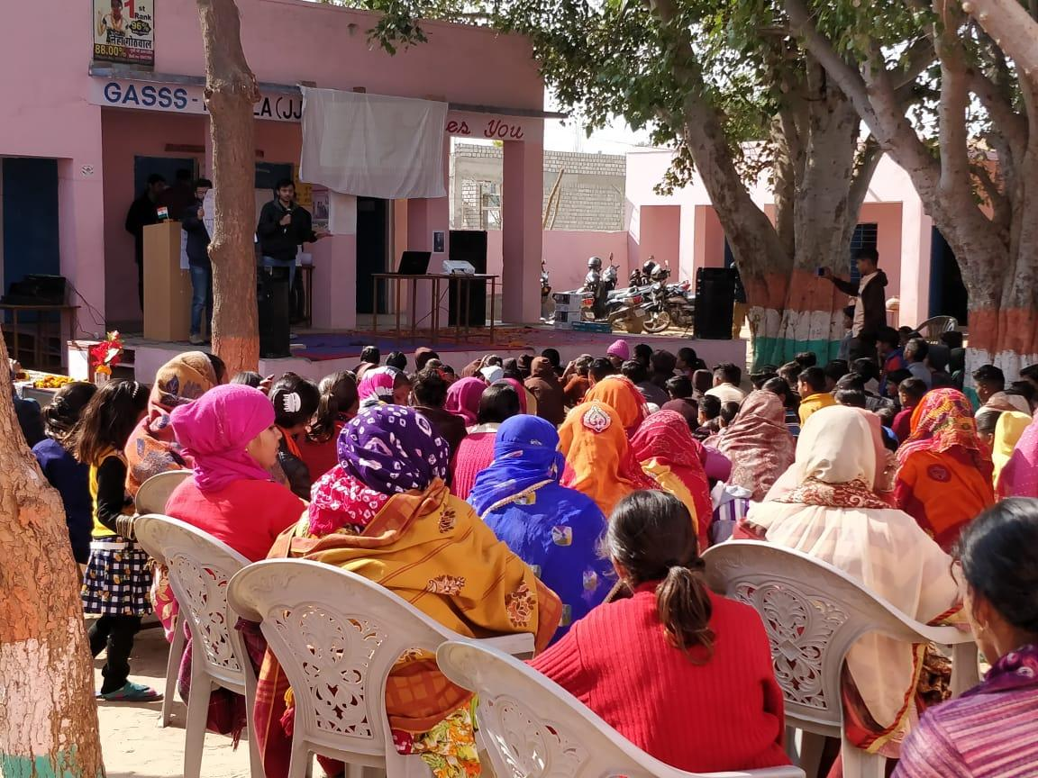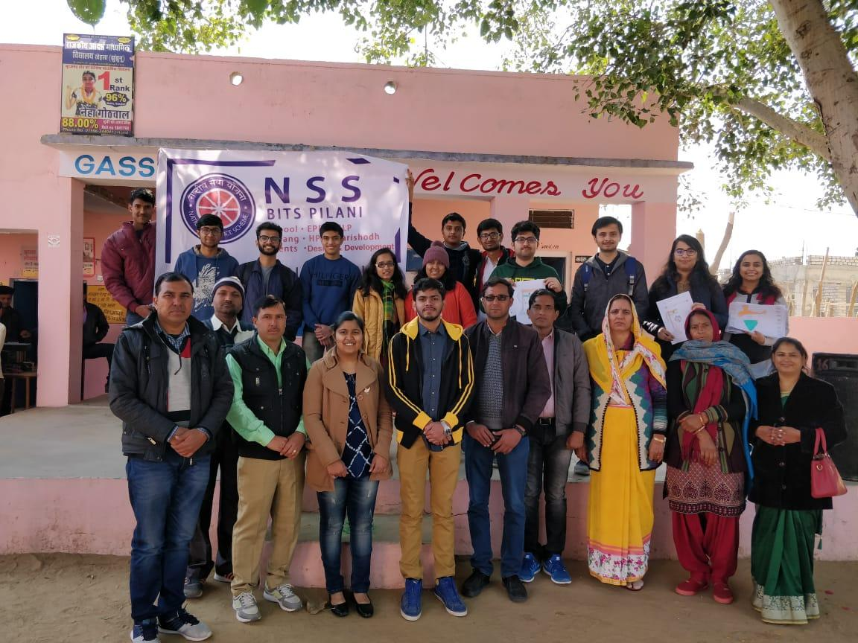
Independence Day Celebration in Government School.

Government School Program:
The origin of Government School Program (GSP) is attributed to the lack of cheap/free basic primary education in Pilani. GSP aims at uplifting the conditions of government schools in and around Pilani in terms of infrastructure, academic planning, and execution. Weekly Workshops in collaboration with English and Personality Development department were conducted to boost the confidence of students and develop their thought process by introducing them to new ideas and by having discussions.

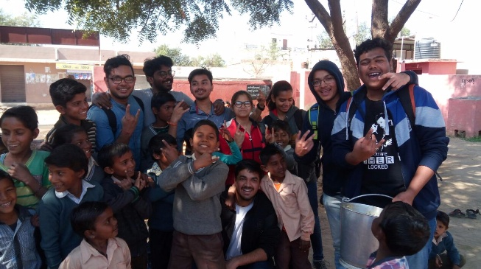
Volunteers interacting with the kids of Government School

Republic Day Celebration in Harinagar:
Republic Day celebration on 26th January began with a speech by NSS volunteers. Their speeches explained the importance of the constitution to the students of the school. Students were acquainted with a short clip on parades held in Delhi on Republic Day. Clothes were distributed among the students by NSS volunteers.
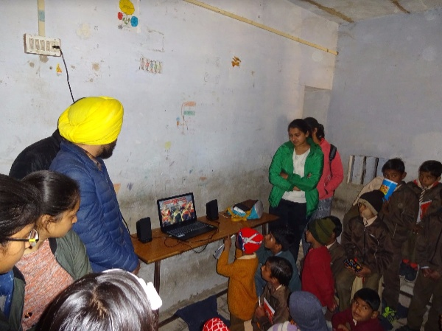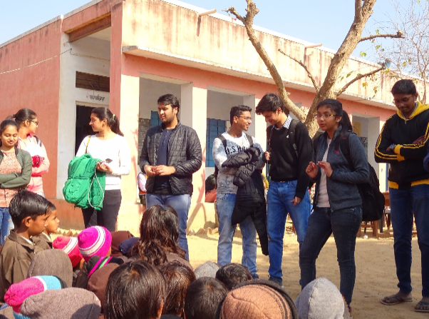
Volunteers interacting with the students

  - RAYLA
Independence Day Celebration:
Volunteers went to government school in Rayla village to celebrate Independence Day with the students. The event was started by volunteers presenting a skit based on moral value in front of students and followed by playing different sorts of games with them. The purpose was to bond with with them and to informally talk with them regarding cleanliness and its importance in surroundings.
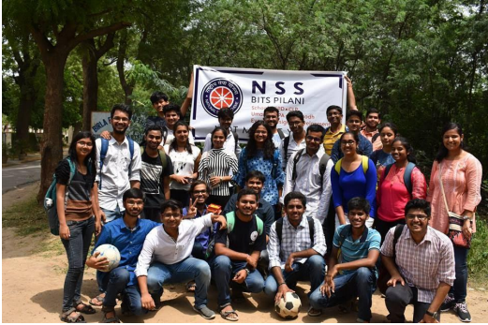
NSS volunteers after successful celebration of Independence Day

Health Camp in Rayla:
Health Camp was conducted in Rayla to provide free check-ups and free medication to the villagers. Health problems were looked after by the doctors Dr R.P. Pareek and Dr. Mukesh Saini. Glucometer was also available to check sugar levels of the blood. The camp was held for 3 hours on 27th January, 2019. 122 people were successful this service. Doctors also gave a lecture on health and hygiene. They also suggested good hygiene habits to the villagers. Clothes were also distributed to the needful adults simultaneously.
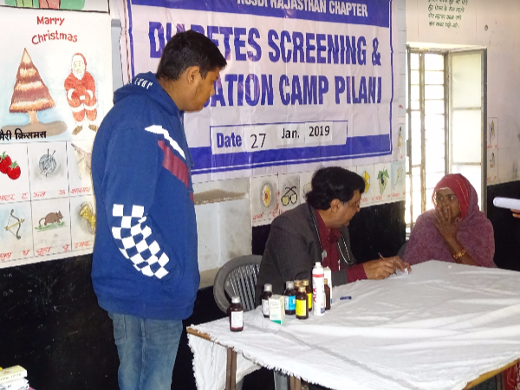
Doctor checking the patients

Computer Literacy Program (CLP):
To redefine the way students, think of coding and its applications, NSS BITS Pilani, conducted a workshop on the use of Scratch. The aim of the workshop was to teach them how to logically approach a problem, solving step by step. Scratch according to experts is one of the most befitting ways to introduce anyone to the world of programming. It helps to visualize different programming concepts in an effortless and effective way.
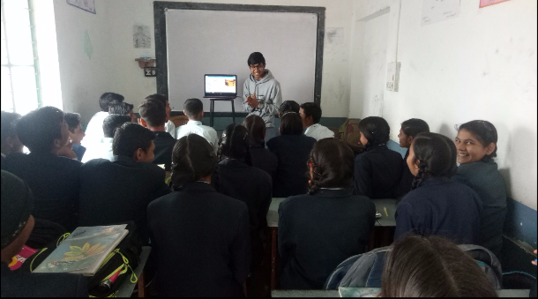
Volunteers interacting with students

Sports Day in Rayla Government School:
Keeping in mind the overall development of the students, NSS organized the sports day in the Rayla Government School on 8th November 2018. With the participation of about 50+ students, we successfully hosted the games like cricket, football, Kho-Kho, musical chair, etc. keeping in mind that every student should be able to participate in some activity. Towards the end, prizes were given away to the winners.
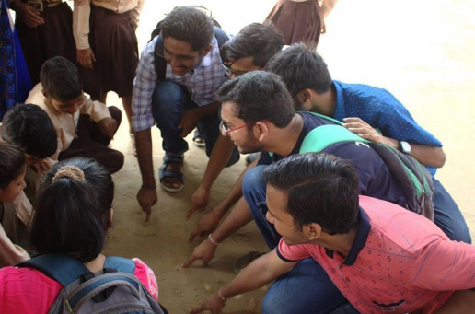
NSS Volunteers playing with children

  - GARINDA
Swachch Bharat Mission:
NSS BITS Pilani visited primary school of Garinda on 11th August, 2018 to share with the students the knowledge of basic sanitation and hygiene standards. A lecture was delivered on importance of keeping oneself and the surroundings clean. It was followed by demonstration of proper procedure to clean hands using soaps and soaps were provided by the team to be installed in school washrooms. A short session was also conducted for girls of 6th, 7th and 8th standard on menstrual hygiene.
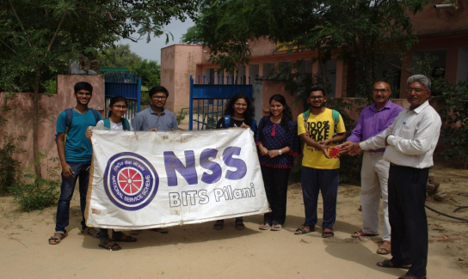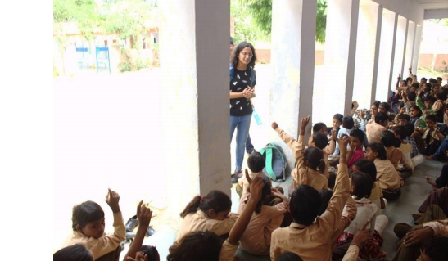
Volunteers spreading awareness about Hygiene and Cleanliness

Independence Day Celebration:
A program based on the theme of “Swachh Bharat” was conducted on the occasion of 72nd Independence Day of India in village Garinda. Volunteers explained the importance of cleanliness in promoting a nation’s growth and maintaining a healthy community by performing a skit. The principal of the school also shared his views on how to ensure proper waste disposal and management in the village. Small competitions including slogan writing and short poetry based on the same theme were organized.
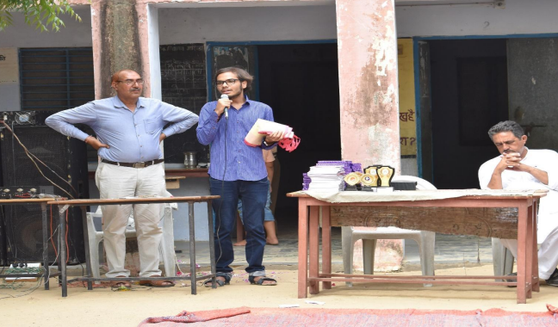
Volunteer explaining the importance of cleanliness to the students

CLP Publicity in Garinda:
NSS volunteers conducted a publicity drive on 17th October 2019 to spread the awareness about the CCC program in Garinda in the evening. Pamphlets distribution and door-to-door publicity were organized near various schools, shops, and tuition centres.
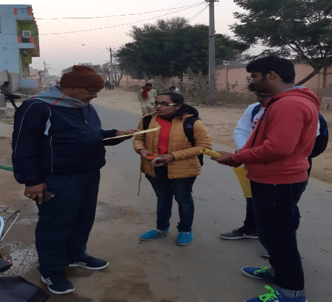
Volunteers interacting with villagers

Lecture Series in Village:
Lecture series is an initiative taken by NSS volunteers to create public awareness in villages. In the month of February, the lecture was conducted on “Good touch, bad touch” and “Bullying”. This helped students to understand the difference between good touch and bad touch. Students also conducted question and answer session after delivering the lecture.
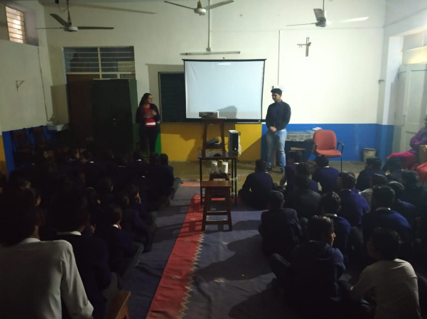
Volunteers giving lecture to the students

- JHERLI
Gandhi Jayanti Celebration:
On the occasion of Gandhi Jayanti, NSS volunteers visited school in Jherli to give a lecture on the teachings of Gandhi Ji specially focusing on his habits and his values for cleanliness. Students and volunteers cleaned the school and then a drawing competition was also organised for the students to draw anything of their will relating to Mahatma Gandhi.

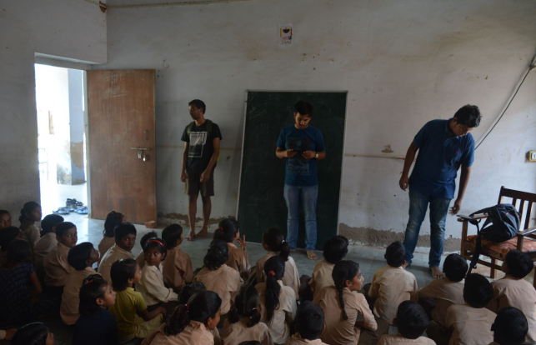
Volunteers giving lecture in Jherli School

Government School Program:
Government School Programme was started with an aim to teach basic English to students of Government Schools around Pilani. For this initiative, NSS had chosen Jherli Government School. The topic covered include importance of English, sentence structure, verbs and vocabulary.
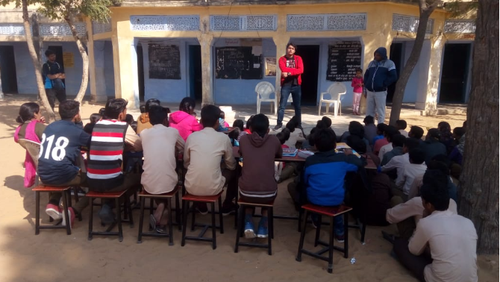
NSS Volunteer interacting with students in initial GSP classes

Green School Initiative:
Volunteers at NSS BITS Pilani organised a "Green School Initiative" to teach the school students of village Jherli about how to plant saplings and seeds and to take care of their growth. Each student planted a sapling and poured water under the guidance of NSS volunteers. In total 60 saplings were planted. After that the volunteers showed them hoe seeds are grown by sowing seeds in the ground. Through this initiative, we not only plan to contribute towards better environment but also teach the students the importance of the same.
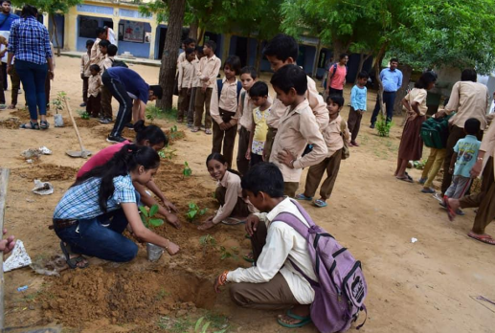
NSS Volunteers teaching students how to plant saplings.

Computer Literacy Program (CLP):
To be able to impart what you have is the kindest thing you can do. NSS, BITS PILANI, conducted a seminar on PowerPoint Presentation. The aim of the seminar was to make students aware of the basic options available in PowerPoint and being able to use as per their requirement. The seminar was conducted on 28th February, for the students of Class 8th. The students were first explained about the features of PowerPoint and given a demo on how to use them simultaneously.
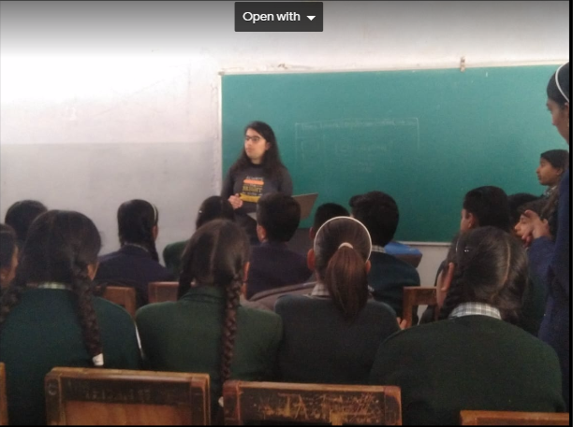
Volunteers interacting with students

Lecture on Good Touch – Bad Touch:
To aware the children about sexual child abuse in a subtle and understanding wave, NSS organized an interactive workshop on the topic “Good Touch Bad Touch.” The lecture included the difference between good and bad touch, how to identify bad touch, how to deal with it when experienced and how it is never their fault.
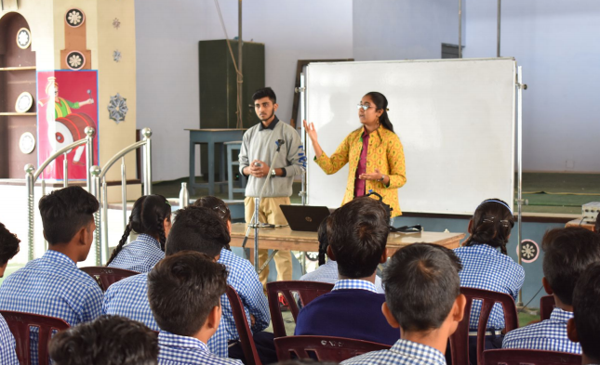
Volunteers delivering workshop

Awareness rally for Blood Donation:
A rally was organized by NSS volunteers in village of Jherli to spread awareness about the importance of blood donation and motivate people to participate in Blood Donation Camp. The rally began by using the slogans related to blood donation to get the attention of the residents and then some volunteers passing them the information
about the camp.

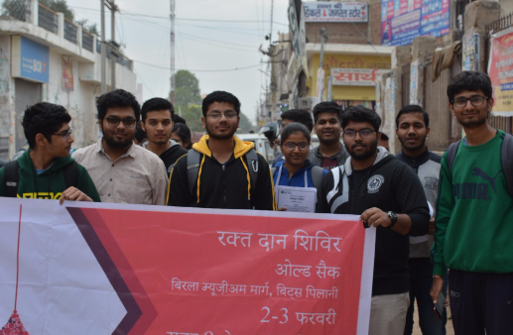
Volunteers conducting rally for Blood Donation Camp
- BHAAS

Government School Initiative:
With the vision of redefining computer literacy on rural grounds, CLP, NSS BITS Pilani started its Government School initiative in the Government School of Bhaas. It aims to build a strong foundation for Computer Learning among children. A team of volunteers ensures that the class is well seated, disciplined and learns at a manageable pace. Through this initiative, we hope to successfully impart computer knowledge to these zealous children.
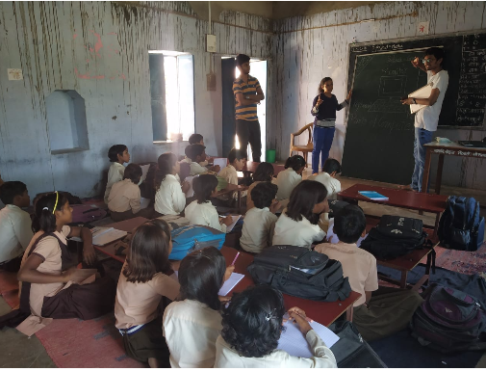
Volunteers teaching in the Government School

Project BHOOMI:
BHOOMI aimed at building a cost-effective soil testing machine. This would prove to be a boon for the economically challenged farmers in the state. This ambitious project is still in its initial stages. We recently conducted pH testing on acquired soil samples from nearby village of Bhaas. The soil samples were also prepared to conduct experiments for NPK.

Scheme Portal:
NSS BITS Pilani organized a Portal session in Bhaas in which we invited people from different age, income, group, and gender to try the portal. 27 People successfully tried out the portal, and the working of the portal was recorded along with the user’s feedback. Despite some Internet connectivity issues and other small technical issues, we were able to try out the portal and gather data.
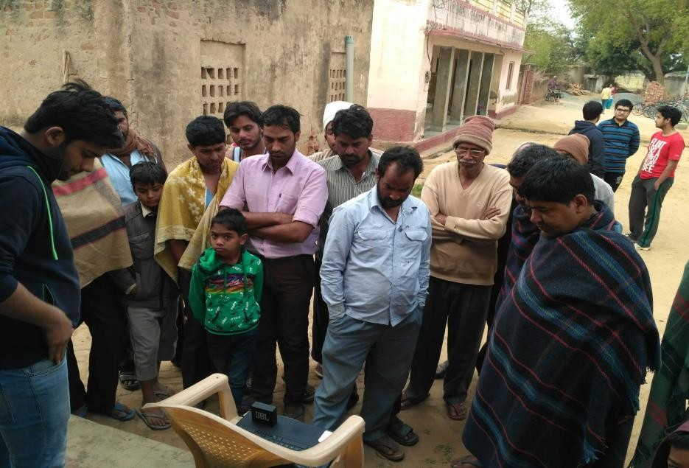
Villagers trying out the Scheme Portal

Counselling Sessions:
These sessions were aimed at guiding the students and showing them a path towards a bright future. Also, it focused on making their base strong to help them prevail in this competitive world. Tips related to the upcoming board exams were given through a unique skit that helped the students a lot. Lastly generous feedback from the students was collected through a form in NSS School. It has been implemented this time to get a rating for the session and the speakers, hence improving the group's initiative.
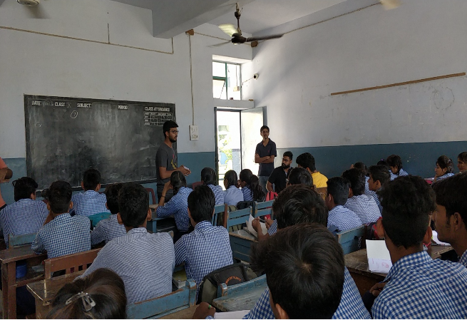
Counselling sessions held in Bhaas School

Computer Literacy Program (CLP):
Expression of thoughts and ideas is equally important as the ideas themselves are,\ so NSS BITS Pilani, conducted a workshop on the application PowerPoint Presentation as required by the school. The aim of the workshop was to teach them how to express ideas effectively through Presentation. Students were taught about different features of MS PowerPoint through which they can display their thoughts and ideas in the form of presentation more effectively in an attractive manner.

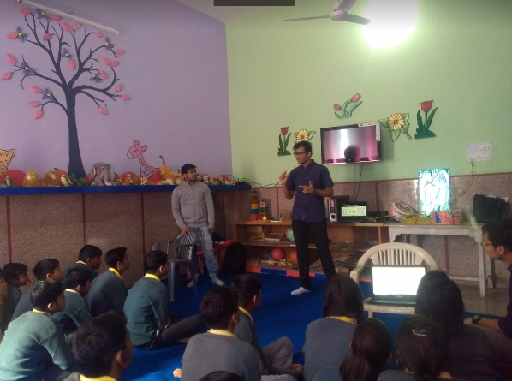
Seminar being Conducted
  - GHUMANSAR
CLP Publicity Drive in Ghumansar:
CLP along with the new recruits conducted a publicity drive on 21st September 2018 to spread awareness about the RSCIT program. RSCIT is a three-month long Rajasthan government certified computer course conducted by RKCL which aims at providing education regarding the basic computing skills necessary for jobs. Pamphlets distribution and door-to-door publicity were organized near various schools, shops, and tuition centres. The drive was quite successful as we were able to inform the villagers about the course and its benefits. This drive will play an important role in increasing the computer literacy.

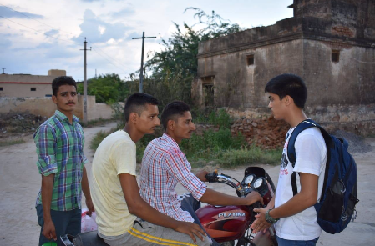
Volunteers spreading awareness about the course

Lecture on ‘Anaemia: Symptoms and Precautions’:
With 51% of Indian Women affected by Anaemia, India tops the list of highest number of anaemic women and children. With the aim to educate villagers about symptoms of the disease and the measures one should take to avoid the disease, NSS conducted a lecture for the same in village Ghumansar.

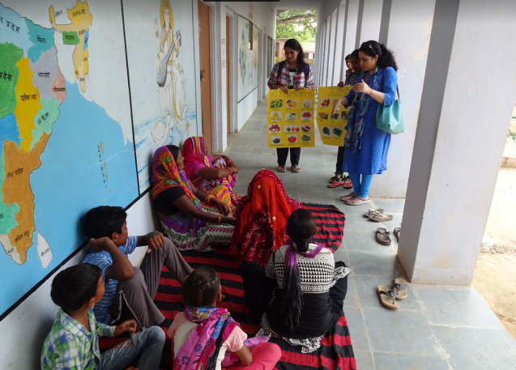
Doctor delivering talk to villagers

Documentation Camps:
Documentation camps were held in the month of August. The aim of this project is to provide access to education for the most underprivileged section of society living in small bastis. Under this project, a basti having children who are of school going age but are either dropouts or have never been to school was identified. The aim of the project is to search for a nearby government school and get these students admitted after convincing their parents and completing the formal procedures and document work. The simple aim of this project is to make education accessible to all.
A survey was conducted in the two bastis on 19th August in order to know which documents were needed and the documentation camp was conducted in both the bastis simultaneously. The following documents were made- Bhamasha card, Birth certificate, Aadhar card, Mulnivas Patra and Jati Praman Patra during the documentation camp conducted on 23rd August. These documents will further be used in the paperwork for admitting the children of these bastis to nearby government schools.
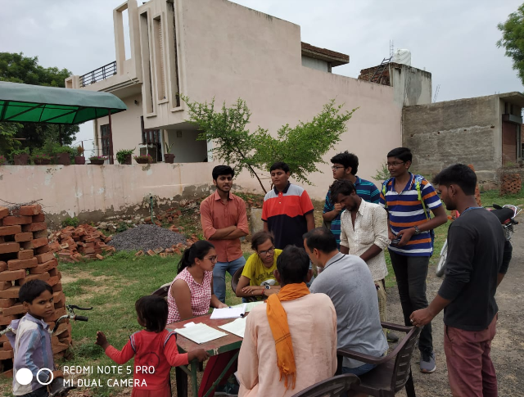
Forms for the required documents being filled

Adult Initiative:
Adult education is an initiative which deals with giving basic education to adults who are not acquainted with habits of reading and writing. Volunteers are taking efforts to improve this side of literacy of people in the villages. Subjects like English and Hindi are majorly focussed on, and general awareness is also included.
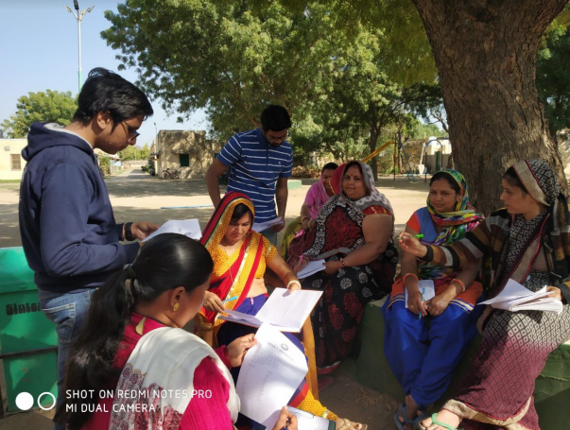
Volunteers teaching adults the basics of English

Mechanisms / Systems for Social Involvement:

- NSS:
- No. of students: 704
- No. of activities conducted last years: 39

Name of Social Outreach Programme:
- Blood Donation Camp:
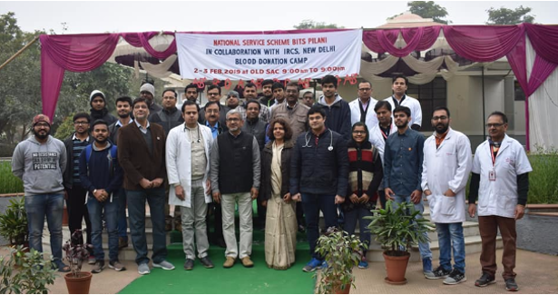
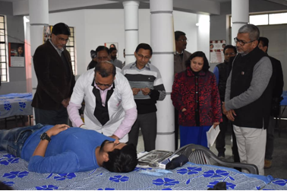
The Blood Donation Camp 2019 (BDC 2019) was conducted by NSS, BITS Pilani, along with the help of Indian Red Cross Society, New Delhi. This was the 38th edition of Blood Donation Camp. The camp took place on 2nd and 3rd February 2019. It was a two-day camp which was open from 9AM to 9PM. The Camp was inaugurated by the Vice-Chancellor, Director and various other Faculty members of BITS Pilani on Saturday 2nd February at 9 AM.

Number of Active Volunteers = 150
Hours/Volunteer = 4 hrs
The camp saw a total of 748 units collected, along with the footfall of over 1000+, which was a great achievement in itself.

- Conferencia de Youth:
With the vision that the it is the people especially the youth who have to safeguard the interests of the nation and of their own, NSS BITS Pilani organized the inaugural edition of “Conferencia de Youth,” a youth conference for the social chapters of different colleges spread across Delhi, Jaipur and other cities. The inaugural edition has the theme as ‘ROLE OF YOUTH IN NATION BUILDING’. There were about 7 outstation colleges which saw a participation of 48 students for the conference.
The conference had a total of 9 events:
- Listen, Talk, Change
- Masterplan
- Code-a-thon
- Educate Empower
- Eloquence
- Mukhaute
- Words of Wisdom
- Volunesia
- Adhyayan

Number of Active Volunteers = 110
Hours/Volunteer = 4.5 hrs

